Automated EEG based Epilepsy detection using deep long short-term memory network

Shilpa Jain1,Aman Tiwari2, Kashish Mirza3, Sandeep Kr. Sunori4

1, 2,3,4Graphic Era Hill University, Bhimtal, India

shilpajain1606@gmail.com

This article proposes automated Epilepsy detection using a deep long short-term memory (LSTM) network. Electroencephalogram (EEG) signals are a valuable resource in neuroscience for understanding brain activity. Approximately 23-channel Electroencephalography (EEG) device is used to detect Epilepsy across 23 subjects. Analyzing EEG signals poses a unique challenge due to their temporal nature and intricate patterns. Long Short-Term Memory (LSTM) networks, a type of recurrent neural network (RNN), well-suited for capturing temporal dependencies in sequential data. LSTM network is used to identify the electrical signals in major regions of brain using five frequency bands. This study investigates the application of LSTM networks to classify EEG signals, aiming to contribute to the field of brain signal analysis.

The results show a maximum accuracy of 98.74% for LSTM networks and 95.42% for CNNs for 100 iterations which is superior to other state-of-the-art techniques found in the literature.

Keywords: Epilepsy, EEG, Machine Learning, Deep Learning, Long short term memory network (LSTM).

Introduction

Epilepsy has a Greek origin which means “to seize”, it’s a chronic brain disorder causing recurrent seizures. Seizure is unusual electrical functionality of brain due to which patient suffers uncontrollable muscle or movements like twisting, limpness etc. It can also lead to changes in movements, behavior, sentiments and consciousness levels. Patient needs to be monitored all the time and it can be a life threatening disease at times. The activity of neurons present in brain can be analysed using devices like electroencephalogram (EEG), Magnetoencephalography (MEG), Electrocorticography (ECoG), functional magnetic resonance imaging (fMRI), and functional near-infrared spectroscopy (fNIRS). MEG is expensive and non-portable, ECoG is invasive in nature, fMRI is expensive, non-portable and has poor temporal resolution and fNIRS is time consuming. Therefore EEG is the most popular choice as its low cost, portable, noninvasive and has high temporal resolution. Conventionally EEG is a test that measures electrical activity in the brain using small, metallic discs called electrodes which are attached to the patient’s scalp. Electrical signals in brain are complex, noisy, nonlinear and voluminous. EEG along with Artificial Neural Networks (ANNs) is used in numerous applications. However, visual inspection of EEGs is time consuming and costly process because of the tons of data included in EEG recordings. Thus, developing automatic seizure detection methods are of great significance for reviewing the EEGs.

Literature Survey

A novel method is devised in this article to automate the process of Epilepsy detection using long short term memory network. Previous works in this direction include, [1, 7] a review is presented on application of machine learning for seizure detection which summarizes as datasets used in the study are of Bonn University, CHB-MIT, Epilepsiae, Institute of Neuroscience India. Techniques frequently used are KNN, SVM, DNN, MLP, NB, ANN further feature extraction techniques include DWT, Multi-DWT, Short Fourier Transform Series, Fast Fourier Transform Series, Empirical Wavelet Transform. Further Sameer et al. [2] applied ID convolutional network to extract features from time series EEG signals and machine learning for classification with an accuracy of 99.83%. Prabhakar et al. [3-5] extracted features and applied LSTM for imagined speech detection. Abdelhameed and Bayoumi [6] gave a deep learning approach using 2-D deep convolutional auto encoder for detecting seizures in pediatric patients. Hossain et al. [8] applied deep CNN model to extract temporal and spectral features from EEG data to detect seizures. Sriraam et al. [9] gave matrix determinant as a significant feature for Epilepsy detection. Subasi et al. [10] used Genetic Algorithms and PSO for feature detection along with SVM for classification of EEG signals. Jaiswal et al. [11] used sub pattern based PCA and cross pattern based PCA with SVM for seizure detection. Wang et al [12] used wavelet decomposition and directed transfer function to reduce dimensionality with SVM classifier. Ullah et al. [13] proposed pyramidal 1D CNN for detecting Epilepsy.

Cerebral activities of 60 subjects were recorded using EEG and their age and gender was determined through LSTM and bi-LSTM [14]. The relationship between statistical parameters and Electroencephalographic (EEG) signals as a function of age, in subjects without neurological disorders [15]. According to Ehlers and Kupfer [16], EEG is potentially important in the evaluation of brain aging for the recognition of structural or functional brain alterations. Nitish and Tong [17] state that the EEG signal has a large amount of information and is essential to develop tools that aid in diagnosing and detecting diseases, so the EEG signal can be an important tool for the diagnosis, exclusion and monitoring of various disorders related to the CNS [18-20].

Material and Methods

Electroencephalogram (EEG) signals are used to understand brain’s activity. Analysis of EEG signals poses a challenge due to its temporal nature and intricate patterns. Long Short-Term Memory (LSTM) networks, are recurrent neural networks (RNN), well-suited for capturing temporal dependencies in sequential data. This study investigates the application of LSTM networks to classify EEG signals, aiming to contribute to the field of brain signal analysis.

**Dataset:** The dataset used in this study comprises EEG signals collected from various samples. Each sample is associated with a binary outcome, and the goal is to train an LSTM network to accurately predict these outcomes based on the input EEG signals.

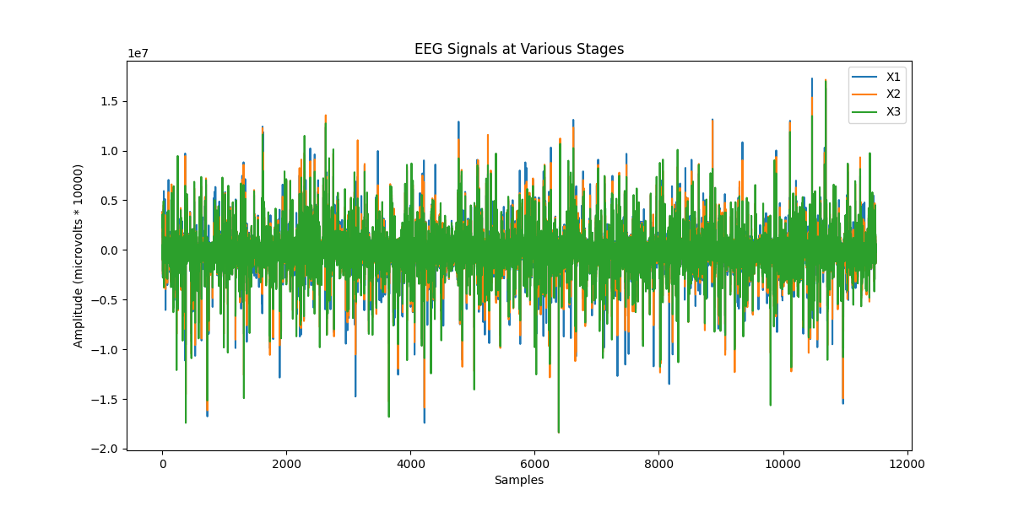**Fig 6. Frequency of the samples throughout the data**

**The 4 type of brain waves namely Beta, Alpha, Theta, Delta were considered as non-epileptic while Gamma rays where considered as epileptic**  The dataset is preprocessed to facilitate model training, including standardization of features and encoding of categorical labels using Label Encoder.

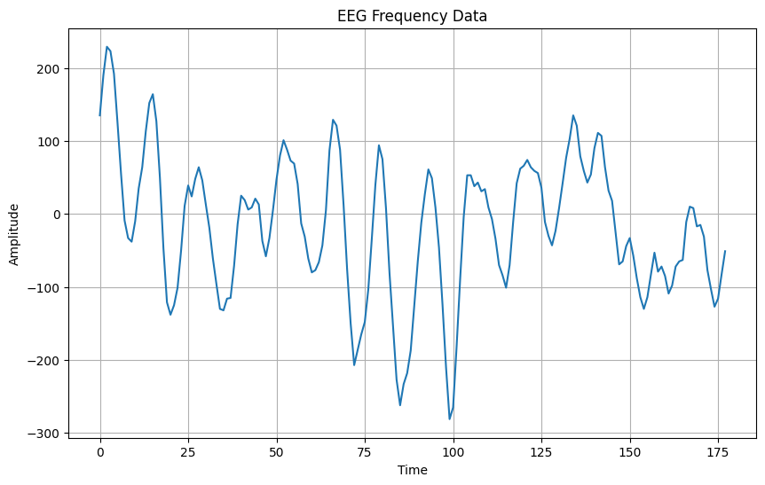

**Fig. 1 Frequency at different time while recording the EEG data**

**Model Architecture:** The LSTM-based neural network is constructed using the TensorFlow and Keras libraries. The architecture consists of three LSTM layers with Batch Normalization and Dropout layers to enhance the model's generalization capabilities and prevent overfitting. The final layer is a dense layer with a sigmoid activation function for binary classification. The model is compiled using the Adam optimizer and binary cross-entropy loss function.

**Experimental Procedure:**

1. **Data Preprocessing:** The EEG signals are preprocessed by standardizing the features using StandardScaler and encoding the binary labels with LabelEncoder.
2. **Model Construction:** The LSTM model is built with three stacked layers, each followed by Batch Normalization and Dropout layers. The architecture is designed to capture temporal dependencies in the EEG signals.
3. **Model Training:** The dataset is split into training and testing sets. The training set is further divided into training and validation sets. The model is trained using the training set, with early stopping implemented to prevent overfitting.
4. **Evaluation:** The trained model is evaluated on the test set, and the classification accuracy is calculated using the accuracy_score metric.

**Results and Discussion:**

**The LSTM-based neural network is constructed using the TensorFlow and Keras libraries. The architecture consists of three LSTM layers with Batch Normalization and Dropout layers to enhance the model's generalization capabilities and prevent overfitting. The final layer is a dense layer with a sigmoid activation function for binary classification. The model is compiled using the Adam optimizer and binary cross-entropy loss function.

**Fig. 2 Results of CNN model Fig. 3 Results of LSTM model**

Model: "sequential"

_______________________________________________________________

Layer (type) Output Shape Param #

=================================================================

lstm_15 (LSTM) (None, 1, 100) 112000

batch_normalization_19 (None, 1, 100) 400

dropout_19 (Dropout) (None, 1, 100) 0

lstm_16 (LSTM) (None, 1, 100) 80400

batch_normalization_20 (None, 1, 100) 400

dropout_20 (Dropout) (None, 1, 100) 0

lstm_17 (LSTM) (None, 50) 30200

batch_normalization_21 (None, 50) 200

dropout_21 (Dropout) (None, 50) 0

dense_9 (Dense) (None, 1) 51

=================================================================

Total params: 223651 (873.64 KB)

Trainable params: 223151 (871.68 KB)

Non-trainable params: 500 (1.95 KB)

The experimental results demonstrate the effectiveness of the LSTM-based model in accurately classifying EEG signals. The training and validation accuracy curves indicate that the model successfully learns the temporal patterns in the data without over fitting. The test accuracy, measured using accuracy_score, provides a quantitative assessment of the model's performance on unseen data.

_________________________________________________________________

Algorithm Iterations Accuracy ================================== ===============================

Convolutional Neural Network(CNN) 100 95.42

Long Short Term Memory (LSTM) 100 98.74

=================================================================

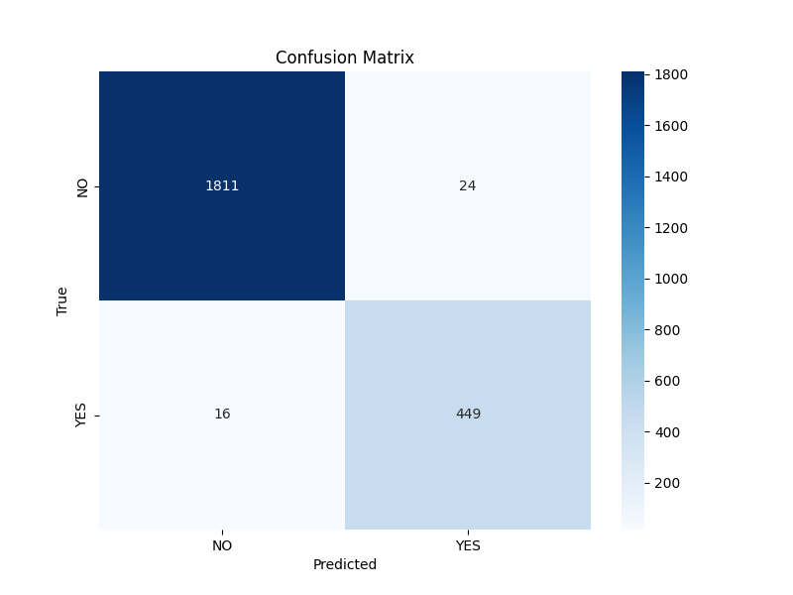**Fig 4. Heatmap of Confusion Matrix produced by LSTM**

Conclusion and Future Scope

Automation of classification of EEG signals is valuable in healthcare domain. We have developed a solution to detect Epilepsy using LSTMs. Stating the conclusion that can be drawn from this study. The accuracy with which the LSTM model performed is 98.74% in comparison to CNNs with accuracy of 95.42%. In order to seek better results in future we will apply transformers to the current study. It can further be applied to accurate dose detection for Epileptic kids which can reduce the span of dose intake for Epileptic kids.

References

1. Farooq, M. S., Zulfiqar, A., & Riaz, S. (2023). Epileptic Seizure Detection Using Machine Learning: Taxonomy, Opportunities, and Challenges. *Diagnostics*, *13*(6), 1058.

2Sameer, M. and Gupta B. (2022). CNN based framework for detection of epileptic seizures. Multimedia Tools and Applications, 81, 17057-17070, doi 10.1007/s11042-022-12702-9.

P Agarwal and S. Kumar, “Electroencephalography-based imagined speech recognition using deep long short-term memory network,” ETRI Journal (Wiley), vol. 44, no. 4, pp. 672–685, Apr. 2022, doi: 10.4218/etrij.2021-0118.

P.Agarwal and S. Kumar, “Electroencephalography based imagined alphabets classification using spatial and time-domain features,” International Journal of Imaging Systems and Technology (Wiley), vol. 32, no. 1, pp. 111–122, Jan. 2022, url: <https://doi.org/10.1002/ima.22655>

5P. Agarwal and S. Kumar, “Transforming Imagined Thoughts into Speech Using a Covariance-Based Subset Selection Method,” Indian Journal of Pure & Applied Physics (CSIR-NIScPR), vol. 59, no. 03, pp. 180–183, Mar. 2021, url: [http://nopr.niscair.res.in/handle/123456789/56517.](http://nopr.niscair.res.in/handle/123456789/56517.()

6 Abdelhameed, A., & Bayoumi, M. (2021). A deep learning approach for automatic seizure detection in children with epilepsy. *Frontiers in Computational Neuroscience*, *15*, 650050.

7Shoeibi, A., Khodatars, M., Ghassemi, N., Jafari, M., Moridian, P., Alizadehsani, R., ... & Acharya, U. R. (2021). Epileptic seizures detection using deep learning techniques: A review. International Journal of Environmental Research and Public Health, 18(11), 5780.

8 Hossain, M. S., Amin, S. U., Alsulaiman, M., & Muhammad, G. (2019). Applying deep learning for epilepsy seizure detection and brain mapping visualization. *ACM Transactions on Multimedia Computing, Communications, and Applications (TOMM)*, *15*(1s), 1-17.

9 Sriraam, N., Hegde, A. S., and Kubben, P. L. (2019). A novel approach for classification of epileptic seizures using matrix determinant. Exp. Syst. Appl. 127,323-341. doi:10.1016/j.eswa.2019.03.021.

10.Subasi, A., Kevric, J., & Abdullah Canbaz, M. (2019). Epileptic seizure detection using hybrid machine learning methods. *Neural Computing and Applications*, *31*, 317-325.

11 Jaiswal, A. K., & Banka, H. (2018). Epileptic seizure detection in EEG signal using machine learning techniques. Australasian physical & engineering sciences in medicine, 41, 81-94.

1. 12 Wang, D., Ren, D., Li, K., Feng, Y., Ma, D., Yan, X., et al. (2018). Epileptic seizure detection  in long- term EEG recordings by using wavelet- based directed transfer function. IEEE Transact. Biomed. Eng. 65,2591-2599. doi: 10.1109/tbme.2018.2809798.

13. Ullah, I., Hussain, M., & Aboalsamh, H. (2018). An automated system for epilepsy detection using EEG brain signals based on deep learning approach. *Expert Systems with Applications*, *107*, 61-71.

14 Kaushik, P., Gupta, A., Roy, P. P., & Dogra, D. P. (2018). EEG-based age and gender prediction using deep BLSTM-LSTM network model. IEEE Sensors Journal, 19(7), 2634-2641.

15 L. R. M. D. Paiva, A. A. Pereira, M. F. S. D. Almeida, G. L. Cavalheiro, S. T. Milagre and A. D. O. Andrade, "Analysis of the relationship between EEG signal and aging through linear discriminant analysis (LDA)", *Revista Brasileira de Engenharia Biomédica*, vol. 28, no. 2, pp. 155-168, 2012.

16. Ehlers CL, Kupfer DJ. Effects of age on delta and REM sleep parameters. Electroencephalography and Clinical Neurophysiology. 1989; 72:118-25. http://dx.doi.org/10.1016/0013-4694(89)90172-7

17. Nitish VT, Tong S. Advances in Quantitative Electroencephalogram analysis methods. Annual Review of Biomedical Engineering. 2004; 6:453-95. PMid:15255777. <http://dx.doi.org/10.1146/annurev.bioeng.5.040202.12160>

18 Bennys K, Rondouin G, Vergnes C, Touchon J. Diagnostic value of quantitative EEG in Alzheimer's disease. Clinical Neurophysiology. 2001; 31:153-60. <http://dx.doi.org/10.1016/S0987-7053(01)00254-4>

19 Bonanni L, Thomas A, Tiraboschi P, Perfetti B, Varanese S, Onofrj M. EEG comparisons in early Alzheimer's disease, dementia with Lewy bodies and Parkinson's disease with dementia patients with a 2-year follow-up. Brain: A Journal of Neurology. 2008; 131:690-705. PMid:18202105. http://dx.doi.org/10.1093/brain/awm322

20 Dauwels J, Srinivasan K, Reddy MR, Musha T, Vialatte FB, Latchoumane C, Jeong J, Cichocki A. Slowing and loss of complexity in Alzheimer's EEG: Two sides of the same coin? International Journal of Alzheimer's Disease. 2011; 2011: 539621. http://dx.doi.org/10.4061/2011/539621